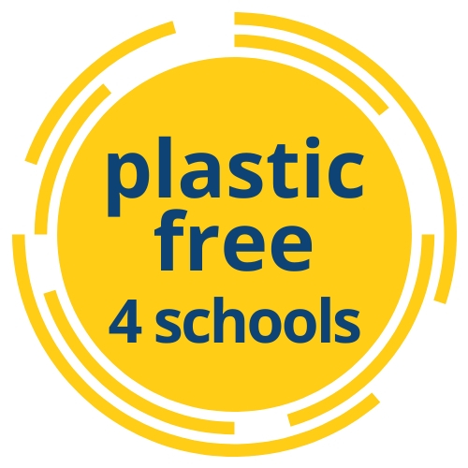

Primary School Workshop Outline
Workshop objective: to raise awareness of plastic pollution and its impacts on the environment and human health and to empower students to be part of the solution through simple actions they can take at home and in school.
Preparation: Use the outline below to prepare your plastic free workshop. Using the steps below it should be possible to deliver the workshop to a class in approximately 30 minutes.
Activities:
- Introduction to plastic pollution – Prepare some facts and stories covering single-use plastics, necessary and unnecessary plastics and alternatives.
  - Use the posters in the resources section for key facts
  - Consult the resources listed at the end of this workshop guide for ideas
  - This activity can take the form of a group discussion

- Meet the Pollutoys and learn about the impacts of marine pollution on sea life.
- If you have resources to purchase some Pollutoys they are a great resource – if not skip to the next step.

- Sand tray activity – use containers, boxes or empty drawers and play sand to set up this activity. Add items of typical marine litter to the trays and some naturally occurring shells and stones. Ask students to identify the plastics that we typically find on a beach, talk about how they get there and where they might come from.
  - The top 10 items found on beaches in the EU are: i) cigarette butts; ii) caps and lids; iii) plastic drink bottles; iv) plastic bags; v) food wrappers and containers; vi) cups, plates, forks and knives; vii) glass bottles; viii) straws and stirrers; ix) drink cans; x) paper bags. Fishing related items like nets and buoys are also common on Irish beaches.
  - This is a link to an infographic on the sources of marine litter https://cleancoasts.org/wp-content/uploads/2018/11/ML_Sources_Inforgraphic_HighRez-e1541672776307.jpg
  - This is a hands-on group activity.

- Understanding degradation – using the litter found in the sand trays guess the degradation time of some typical items of marine litter.
  - Use the worksheet in the resources section to see if you are correct.
  - This can be an activity for groups or pairs.

- Let’s talk about the solutions. Get inputs and ideas from the class on how to avoid unnecessary plastic. Everything from no more straws and what you pack in your lunch, to litter picks, birthday parties and recycling.

  - This can take the form of a group discussion

- School commitment - discuss the 3 Plastic Free actions for schools and invite the school staff and students to make the Plastic Free 4 Schools commitment.
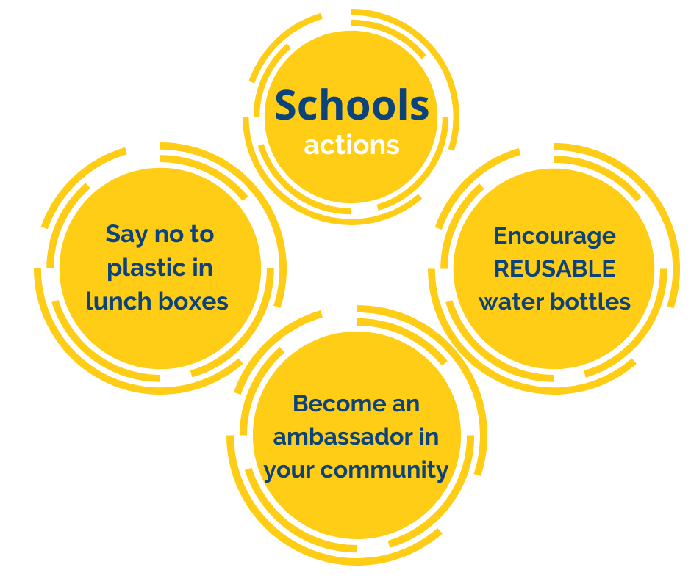

Follow up activities:
- Hold a school poster competition to highlight plastic pollution and the solutions
- Write a letter to an important person in your community to propose a way to reduce single use plastics (e.g. local café, supermarket, St Patrick’s Day parade committee)
- Design new signs for recycling and rubbish bins in your school
- Ask the Green Team to be class champions and remind their classmates about plastic free lunch boxes.
- Ask the Parent’s Association to implement the school’s Plastic Free actions in the activities they organise.

Useful links and further information:
Marliso project : http://www.marlisco.eu/education.en.html
Clean Coasts: www.cleancoasts.org/marine-litter/
Plastic Free Kinsale: www.plasticfreekinsale.com
Plastic Oceans: https://plasticoceans.org
Global Ocean: http://www.globalocean.org.uk/
Sea Strike – The sea has had enough and has gone on strike! This animation is a light-hearted look at what an oceanless world would look like...reminding us why we should take better care of our most valuable resource. It is made by Jane Lee Animations and the MaREI Centre for Marine and Renewable Energy with funding from the Marine Institute through an Ocean Awareness Grant.
https://www.youtube.com/watch?v=2VTlSkqoAh4&feature=youtu.be

