**Advanced Chemistry** **Equilibrium Review** Name_____________________________

Date______________________Hr _____

1. How do the forward and reverse reaction rates compare at equilibrium?_____________________________
2. What is the only way to change the value of the Kc?
3. As a rule, which phases are **not** included in the equilibrium constant expression?
4. Consider the following equilibrium:

a) Cu2+(aq) + 2Ag(s) ⇄ Cu(s) + 2Ag+ (aq) Kc = 1 x 10-15

b) Pb2+ (aq) + 2Cl- (aq) ⇄ PbCl2(s) Kc = 6.3 x 104

i) Which equilibrium favors products to the greatest extent? ______

ii) Which equilibrium favors reactants to the greatest extent? ______

1. Write the equilibrium expression for: **2A(aq) + B(l) 2C(g) +3D(s)**
2. Determine the Kc for the previous problem If [A] = 0.40, [B] = 0.30, [C] = 0.80 and [D] = 1.5
3. Predict whether reactants of products are favored in the following equilibrium systems

a) CH3COOH(aq) ⇄ H+(aq) + CH3COO-(aq) Kc = 1.8 x 10-5 _________________

b) H2O2(aq) ⇄ H+(aq) + HO2(aq) Kc = 2.6 x 10-12 _________________

c) CuSO4(aq) (+ Zn(s) ⇄ Cu(s) + ZnSO4(aq) Kc = 1037 _________________

1. Shown below is a concentration vs. time plot for the reaction **A ⇌ 2B**. For this reaction is the value of Kc **greater than, less than or equal to 1**?

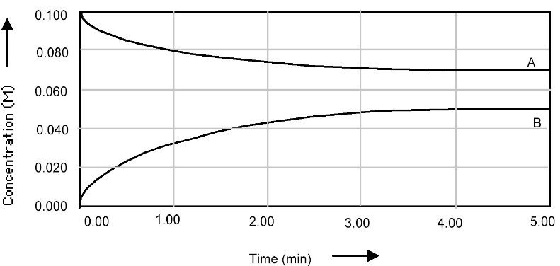

1. Calculate the Kc if the following amounts were found at equilibrium in a **2.00L** volume.

CrO4-2 = 0.0300 mol, H+ = 0.0200 mol, Cr2O7-2 = 0.320 mol, H2O = 110 mol

**2CrO4-2 (aq) + 2H+ (aq)  ⇄ Cr2O7-2 (aq) + H2O (l)**

10. For the following reaction the Kc=120. If [H2] = 0.33 and [Br2] = 0.50, what is [HBr]?

H2(g) + Br2(g)  2HBr(g)

11. If at a certain time [CO] = 0.80, [H2O] = 0.050 , [CO2] = 0.50 and [H2] = 0.40 , is the reaction at equilibrium? If not, how will it shift in order to get to equilibrium

CO(g) + H2O(g) ⇄ CO2(g) + H2(g) Kc= 10.0

12. An equilibrium mixture of contains 0.0010 M CO2 and 0.0015 M O2. What is the equilibrium concentration of CO?

2CO(*g*) + O2 (*g*) ⇌ 2 CO2 (*g*) *Kc* = 140.

1. For the following reaction, what is the equilibrium concentration of **ICl** if 0.75 mol of I2 and 0.75 mol of Cl2 are initially mixed in a **2.00L** flask?

2ICl(*g*) ⇌ I2 (*g*) + Cl2 (*g*) *Kc* = 0.11

1. Predict which way the following equilibrium systems will shift when the **total pressure** is **increased**.

a). ***N2(g) + O2(g)***  ***2NO(g)***......................... Answer__________________

b). ***2SO2(g) + O2(g)***  ***2SO3(g)*** ...................... Answer__________________

c). ***4NH3(g) + 5O2(g)***  ***4NO(g) + 6H2O(g)***....... Answer__________________

15. Hydrogen peroxide is decomposed as follows:

***H2O2(l)***  ***H2(g) + O2(g) H = +187 kJ***

Predict the **direction of equilibrium shift** by each of the following imposed changes:

a) ***Increase*** the [H2] ........................................ Answer _________________________

b) ***Decrease*** the [O2] ....................................... Answer _________________________

c) ***Decrease*** the ***total pressure*** ........................ Answer _________________________

d) ***Increase*** the ***temperature***............................ Answer _________________________

e) Add MnO2 as a ***catalyst***.............................. Answer _________________________

16. Using the following equilibrium, state what would happen to the **equilibrium amountof CH3OH** gas when each of the following changes are made:

***CO(g) + 2H2(g)***  ***CH3OH(g) H = -75.2 kJ***

a) CO gas is added to the container ............................ Answer __________________

b) The *temperature* is increased .................................. Answer __________________

c) The *total pressure* of the system is increased.......... Answer __________________

d) H2 gas is removed from the system......................... Answer ___________________

e) A *catalyst* is added.................................................. Answer ___________________

f) The *total volume* of the container is increased......... Answer ___________________