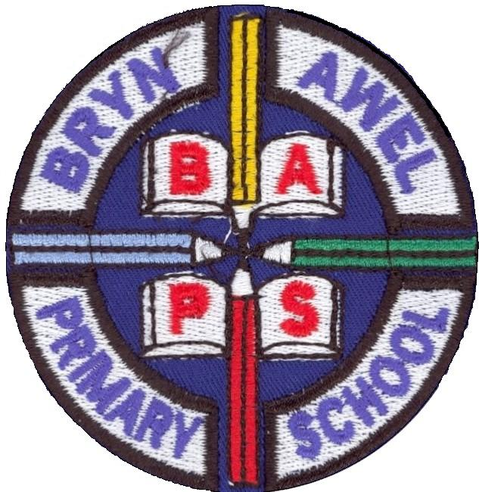
LEGO LEGENDS ACTION PLAN
Apply for Lego League |  | RD
Recruit four members | Four members of staff were asked to join the team and all are eager to participate | Rhian Davies  Linda Williams  Natasha Llewellyn  Kelly Koz
Decide on name for the teams | The Team met and decided upon something clear and simple Lego Legends | RD KK LW NL
Hold a meeting | We held a socially distanced meeting to decide upon our name and how we would decide what our action was going to be | RD KK LW NL
Decide upon the challenge what objectives are, how can it tie in with topic | Our topic this term is Our Wonderful World. The children have enjoyed learning about various animals. As some of us have hedgehogs visiting our gardens we have gathered information about these creatures. The children have been shocked to find they are on the endangered list to the point of extinction. They have taken this on board designing posters, feeding hedgehogs in their gardens and even complaining to Aldi about a misleading advert. | RD KK LW NL
Research ideas and how it will fil topic and what skills it will develop | With the topic in mind we all spent time researching how we could fit in the challenge to develop skills in our topic. | RD KK LW NL
WhatsApp group | Due to circumstances we have found getting together quite difficult. Therefore we set up a WhatsApp group to enable us to share ideas and to pass resources found etc. | RD KK LW NL
Meet to finalise action plan | After a selection of really interesting ideas it was difficult to choose. We got the children to vote to decide which activity they would like to pursue.  They chose the Wildlife crossing as they have found during their research a lot of walk animals are killed on the roads. They would like to investigate ways to make their crossing safe. | RD KK LW NL
Up load team photo | The team photo has been taken and uploaded | RD KK LW NL
Receive funds | Register with IET resource team.  Purchase the Lego WeDo boxes. | RD KK LW NL
Covid safety | The packs will only be used within the class bubble. They will be able to be sterilised weekly in between sessions. They will be stored securely to ensure only the class bubble has access and only they will only be used to explore this investigation. | Class 3
Complete the challenge | Hold weekly sessions to complete the challenge with the class. | Class 3
Evaluate | Evaluate the impact the challenge has had and how it has benefitted the children  What was successful, what would we change next time, | RD, KK, LW, NL

