**](https://steamfund.org/)**

STEAM Fund (Siegel Trust Enriching Arts & Music) at CFOS would like to bring educational programs enriching arts and music to public school children. We offer a variety of workshops and assembly programs as follows.

**THERESA SAREO – “ALIVE AGAIN” Grades 3-12**

[CLICK HERE](https://www.today.com/video/amputee-uses-music-therapy-on-road-to-recovery-53401667888) for a video of Theresa Sareo telling her story on the NBC Today Show

[CLICK HERE](https://youtu.be/raHx8WBsDko) for Theresa Sareo ALIVE AGAIN Official Trailer   
[CLICK HERE](https://cdn.filestackcontent.com/UbgCAV98RKyUgkxiZSCQ) for a Testimonial by Music Teacher Dan Smith

Theresa Sareo, singer/songwriter/trauma survivor, has a powerful story to tell; one that affirms the saving power of following your dreams. After surviving a horrible accident by an impaired driver on a Manhattan street corner that claimed the loss of her entire right leg, Theresa's courageous dedication to her recovery has inspired the amazing journey of her life and career.

She has since become an in-demand motivational performer for audiences throughout the entertainment, educational, medical, corporate, political, civic/law enforcement, faith-based and military communities. By sharing her personal story through her music, Theresa aims to teach, heal and inspire awareness regarding the physical and psychological effects of trauma, and how to navigate through personal life challenges.

The “Alive Again” program includes a 60 minute assembly program. Presentation materials are distributed in advance to the school’s vocal music teacher to prepare students in the chorus and/or general music classes to learn the song “Alive Again” so that they may perform with Theresa at the end of the Assembly program. Time is scheduled for Theresa to rehearse with the students during the day before the assembly program. A Q & A session with a smaller group of students can be included during the day.

**[**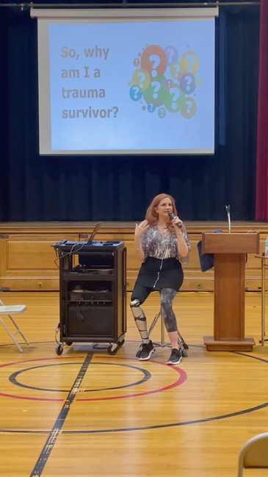

CLICK On Photo

for Video+