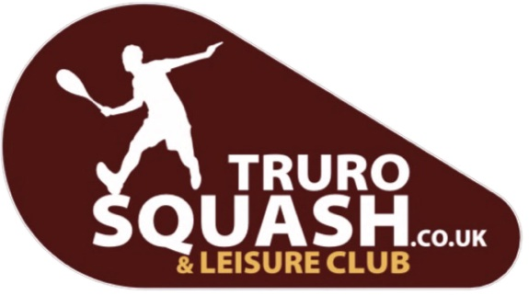
COVID-19 reopening risk assessment

Please also refer to the Government’s COVID-19 Secure Guidance and Maintaining Records Guidance

Area | What are The Hazards? | What are you Already Doing?(Examples listed below) | Further Action is Necessary?(Decide what else you could do) | Action by Who? | Action by when? | Done
Personnel | Risk to returning staff | - Assessment of staff and circumstances carried out including:  - Interviews  - Discover pre-existing conditions  - Regularly briefing staff on latest guidance  - Regularly reminding staff if they have symptoms they must not come to work  - Regularly reminding staff that if they are with someone who has symptoms they must self-isolate and not come to work | Committee member to contact staff to ensure staff are able to return to work.  No further action required | Committee  Committee  Committee  Committee | 14/09/20  On going  On going  On going | Completed week beginning 7/09/20
 | Risk to staff at work | - For general staff protection:  - Developed a detailed plan for the site and communicated to staff.  - Ensured all staff wash hands on arrival and re-entering with staff reminders  - Maintaining a record of staff names, contact details and dates/ times of work to assist NHS Trace and Test.  - Keeping minimum distance from customers in line with Government guidance. Where not possible, other measures are taken.  - Introduced more frequent cleaning regimes  - Reduced the number of people each staff member has contact  - Avoided need to share equipment where possible and disinfected before use | Limited members (6) to be in the bar at any one time. Members to respect social distancing and to be seated at a table. No one is allowed at the bar area.  Hand sanitiser available in the bar area and in the entrance as well as temperature gun.  Staff to fill in time sheet.  Staff to wear face masks and gloves when serving customers. Staff to remain in the bar area and not mix with customers once drinks have been served.  Sanitisers to be on every table. Customers to clean their table before they leave.  Only one staff member in at any time.  Staff to clean the bar after each shift. | Bar manager  Committee  Bar manager  Committee  Bar manager  Bar manager  Bar manager | All needs to be in place by 17.09.20  Completed  On going  All needs to be in place by 17.09.20  All needs to be in place by 17.09.20
Public Bar/ taproom | Risk to staff | - Keeping minimum distance from customers in line with Government guidance. Where not possible, other measures are taken. | PPE available to staff. Customers to remain at their table and drinks to be brought to them. Staff to wear gloves when collecting glasses. | Committee | All needs to be in place by 17.09.20
 | Risk to customers | - Developed a plan for the specific premises to reflect risk assessment | - Cleaning:  Have hand sanitiser dispensers at bar and external doors  Cleaning bar tops every hour and table surfaces immediately after use  Cleaning high throughput areas and touchpoints at least every hour  Emptying glasses collected from table by staff, customers discouraged from returning them to the bar.  - Social distancing:  Limiting capacity to reflect social distancing requirements Taken into account reasonable adjustments for those who need them, such as disabled customers.  Using table service.  - Communication:  Promoting the measures being taken in the venue through signs and informing people on arrival and on website.  Explaining to customers that failure to observe measures will result in service not being provided  Customers to share their details to support NHS Test and Trace.  Offering cashless payment and discouraging the use of cash.  Maintaining a secure and temporary record of customers for 21 days to assist NHS Test and Trace including name of customers or lead member of group, contact phone number, date/ time of visit | Committee  Bar manager  Committee  Bar manager | All needs to be in place by 17.09.20  All needs to be in place by 17.09.20  All needs to be in place by 17.09.20
Customer Toilets | Risk to staff and customers | - Hand sanitiser available on entry to toilets where possible |  |  | completed
Seating area/ dining | Risk to staff and customers | - Calculated a maximum number of persons on the basis of social distancing requirements. Distancing  - Informing customers of access restrictions, social distances and limits on gatherings through sign, on arrival and on website  - Glasses, cutlery and plates picked up only by staff wearing gloves. If no gloves are available, staff wash hands  - Offering cashless payments | New rules limit 6 to the bar area.  Risk assessment to be sent out.  Gloves to be available if staff require | Committee  Committee  Committee | All needs to be in place by 17.09.20
Cellar | Risk to staff and deliverers | Only bottled ale to minimise need to be in the cellar | More frequent cleaning and hygiene.  Have hand sanitiser dispensers at collection area and external doors  Staff wash hands before entering cellar.  Where possible and safe, have a single worker load and unload  Normal practices for maintenance followed and where possible by one person.  Records of visitors maintained. | Committee  Bar Manager | All needs to be in place by 17.09.20
Deliveries received | Risk to staff and deliverers | Bottled Ale only to reduce the need for deliveries | Maintaining distance rules when taking deliveries and where possible verify using digital forms.  Maintaining record of details of deliverers.  Delivery drivers stay in vehicle where possible.  Have cleaning procedures for goods entering the site. | Bar Manager | All needs to be in place by 17.09.20

