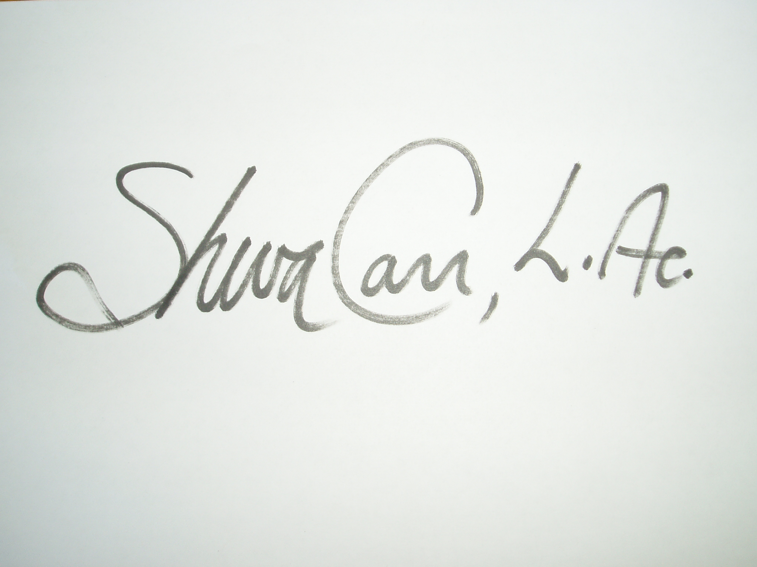

Sheva Carr, L.Ac. APP RPP Polarity Instructor

September 18 and 19, 2016

Shayndel Kahn

## Was completed by

# With 16 Training Hours in Craniosacral Theory, Exercises, & Protocols

Craniosacral Therapy

This Certificate Honors That The Polarity Therapy