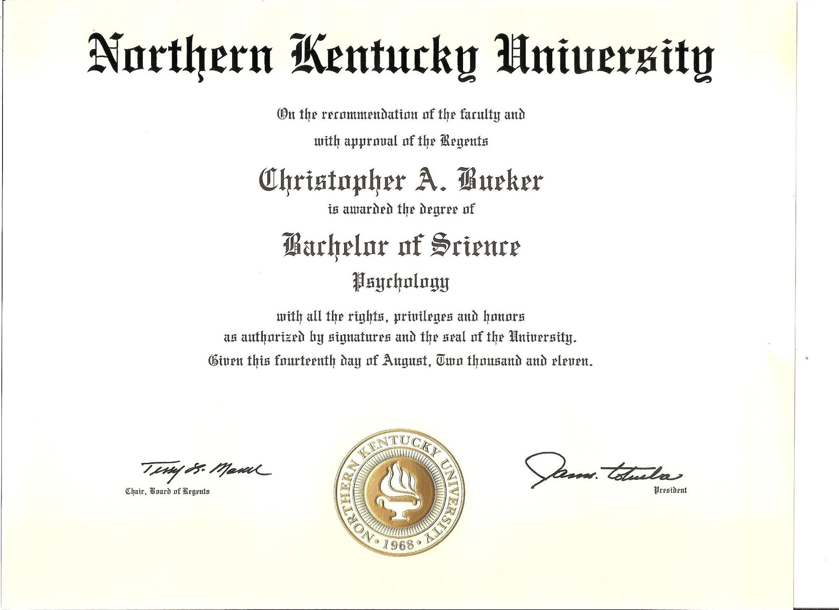
Nurthern Kentuckg łaniuersitu
()it the rerunintentha tint infthe farulig ath
11tith apprattal of the Regents
Christopher A. Wäurker is autarhen the hegree inf 1läarlelur uf Srienre 3|disgrifir milm ug
unith all the rights, piritrileges ath hunture as authorizen hg gigitatures artû İhe gral mf the litittersity.
(Sitten this fnirteenth hay af August, Ourn thmaath anth element.
-ഗല്ലC 52ހޗައިޗިހ/"
(Lhair, Maarà af Regents

