Our Products

BaseballCloud believes that everyone deserves the power and resources of an MLB front office, even if they don’t have millions of dollars to spend. Their first product, BCTeam, was created to help collegiate teams across the country effortlessly manage, analyze, and track ball flight data from anywhere. BCTeam’s revolutionary player portal platform offers players and coaches all of the resources necessary to improve their skills on and off the field—for a price that won’t break the bank.

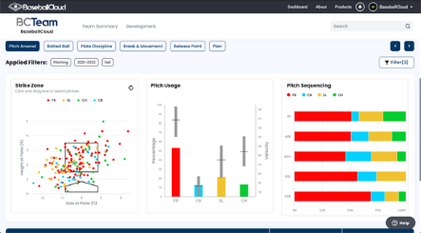
BCTeam’s full suite of features provide users with the ability to filter specific player data, compare and contrast player profiles, and track progress over time. Since launching in 2019, BCTeam has continued to expand its capabilities. Recent updates include the ability to digest data captured from Yakkertech systems, in addition to the creation of summaries for scrimmage, bullpen, and batting practice sessions. Users of the platform also have the ability to create leaderboards that showcase different hitting and pitching metrics.

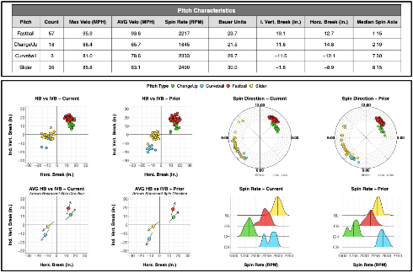
BaseballCloud’s reporting solution, AnalyzR, gives users the ability to design their own reports based on a unique combination of data. It is the only fully customizable option in BaseballCloud’s full suite of products, and makes the process of report creation both flexible and affordable. Users can drag and drop a wide array of raw data into BaseballCloud’s software, immediately generating a customized PDF report that can be dispersed as they see fit. Reports can be designed for internal development, opponent scouting, prospect camps, player valuation and contract negotiation, and much more.

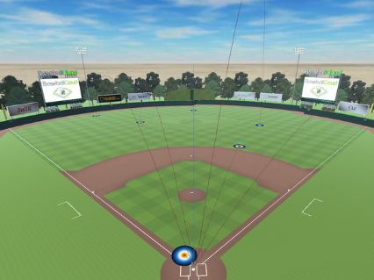
PitchR gives every player and coach the power to create engaging and personalized 3D renditions of complex data sets. After each game or practice, users can ingest their ball flight metrics into the central BaseballCloud platform. Using specific filters chosen by the user, PitchR generates a realistic 3D rendition of the data set that includes access to visuals of specific pitch movements. The analysis can be viewed in BaseballCloud’s original design or can be showcased in a custom field that replicates a team’s home stadium. Players and coaches can analyze every pitch, every swing, and every movement. All from the palm of their hand.
PitchR aims to roll out an extensive set of new features that will enhance user experience and utilization. One of their most exciting advancements incorporates the use of biomechanics, which produce reliable, accurate, and actionable insights into human movement. This game changing technology will help players, coaches, and teams reach their potential by identifying key motion variables associated with stress and fatigue.

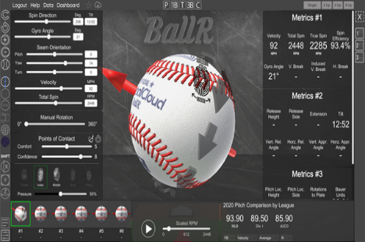
BallR is the most advanced baseball and softball visualization tool in the industry. By incorporating 360 degree and seam only view, BallR gives users the ability to compare pitches, analyze fingerprints, and graph data on the same screen. The patented Point of Contact algorithm calculates advanced metrics and shows players and coaches which grips are affecting each pitch. Users can create new pitches, calculate movement, and view hitter probabilities without lifting a finger.

