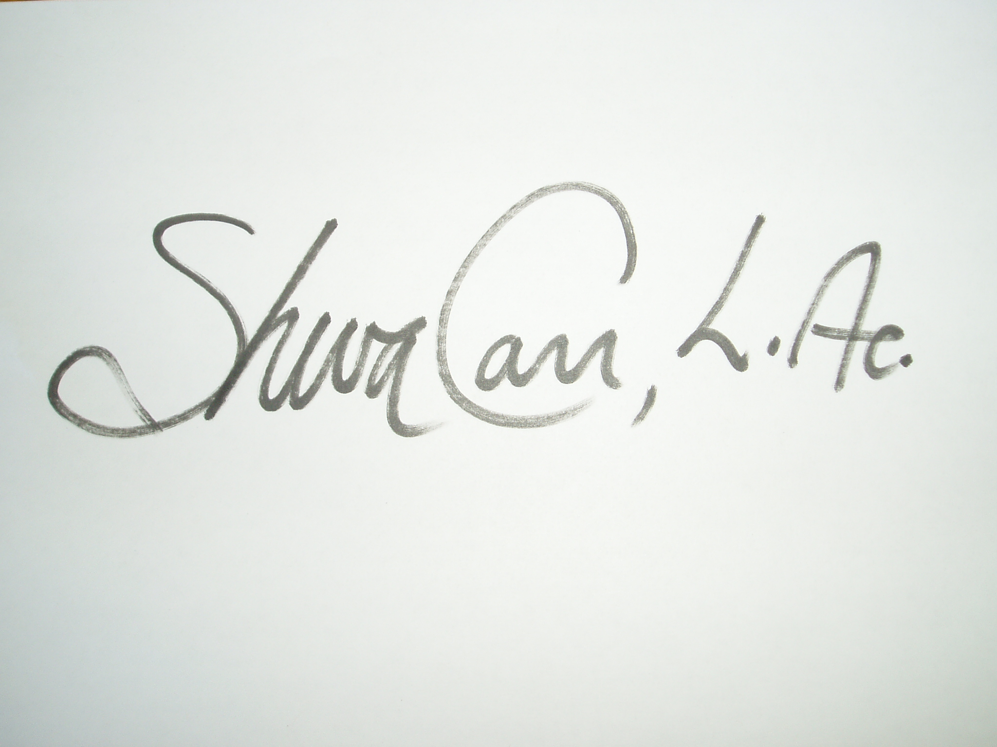

Sheva Carr, L.Ac. APP RPP Polarity Instructor

September 16, 2016

Shayndel Kahn

## Was completed by

# With 8 Contact Training Hours in Basic Theory and General Session

Polarity Therapy Intro

This Certificate Honors That The