55 W Eureka St, Pasadena, CA 91103

May 1, 2021

Dear Aletha,

Congratulations on completing the *Integrative Wellness Coaching Certificate* through the College of Integrative Medicine and Health Sciences, Saybrook University! The International Coach Federation (ICF) has granted this program the designation of an *Approved Coach Specific Training Hours* (ACSTH). You have successfully satisfied 88 hours of required coach education and supervised training on December 7, 2020, which can be applied toward the requirements of an ICF credential.

This program is also an *Approved Transition Program* through the National Board of Health and Wellness Coaching (NBHWC), which qualifies you to apply to sit for the certifying examination and national board certification in health and wellness coaching through the NBHWC.

On behalf of the leadership team and faculty, we wish you the best of luck as you apply the competencies and skills of coaching within the field of integrative medicine.

Sincerely,

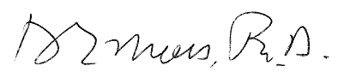



----

Donald Moss, PhD

Dean, College of Integrative Medicine and Health Sciences

Saybrook University

[dmoss@saybrook.edu](mailto:dmoss@saybrook.edu)

Julie A. Cerrato, PhD

Program Director, College of Integrative Medicine and Health Sciences

Saybrook University

[jcerrato@saybrook.edu](mailto:jcerrato@saybrook.edu)