**REPORT ON 2019 WANGARATTA JEWELLERS OPEN RACQUETBALL CHAMPIONSHIPS**

The 2019 edition of the Wangaratta Jewellers Open Racquetball Championships, played at the John Broadway Squash and Racquetball Courts was highlighted by the two Open Champions of 2018 Ryan McCarter and Sue Dunlop, returning and claiming “back to back” Wangaratta Open crowns, the successful move of Jordan Rounds into the A Grade ranks, plus the arrival of the Haberecht family, who shared the weekend spoils with the Brigden, Rounds and Cross/Yallup-Cross families.

The second John Broadway Memorial Award was presented to Geelong’s Garry Pedersen, for his outstanding sportsmanship and support throughout the weekend.

**SINGLES EVENTS**

**SPECIAL PRESENTERS: MATT BARRY (WANGARATTA JEWELLERS) & BARRY PATTERSON (PRESIDENT WANGARATTA SQUASH & RACQUETBALL CLUB)**

MEN’S OPEN

Although this event comprised several players capable of going all the way, the most likely scenario was that last year’s finalists Bayswater’s Ryan McCarter and Geelong’s top seeded Garry Pedersen, would meet in the final stanza, which was the eventual outcome.

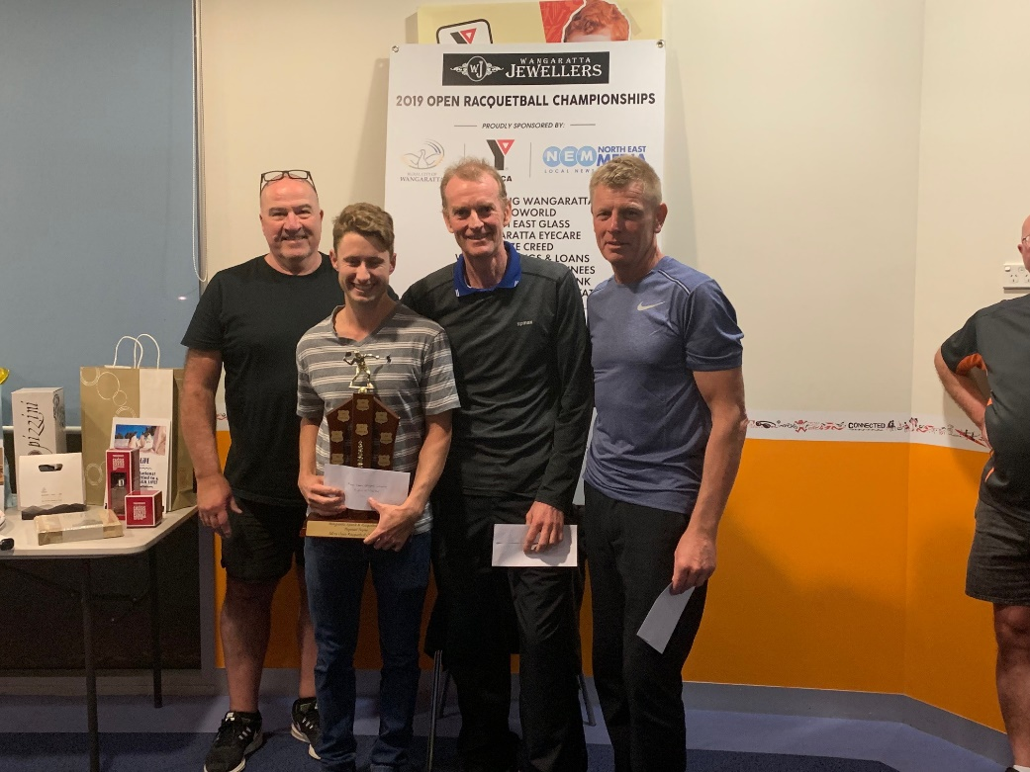Whereas in 2018 McCarter had to come from a game down in the final to overcome the ultra-consistent Pedersen, this year he was on top virtually throughout another enthralling and tough encounter winning in straight games, 21/15, 21/14, claiming his second Wangaratta title, overall his third Victorian GP crown, and catapulting him into top spot on the Victorian Circuit rankings, as well as consigning Pedersen to his eighth successive runners-up position.

To reach the final Pedersen outlasted Lilydale’s fourth seeded Nathan Lindner, 22/21, 21/15, whilst McCarter ousted Wagga’s third seeded Craig Ambler, 21/18, 21/16.

*L-R: Barry Patterson, Ryan McCarter, Garry Pedersen & Craig Ambler*

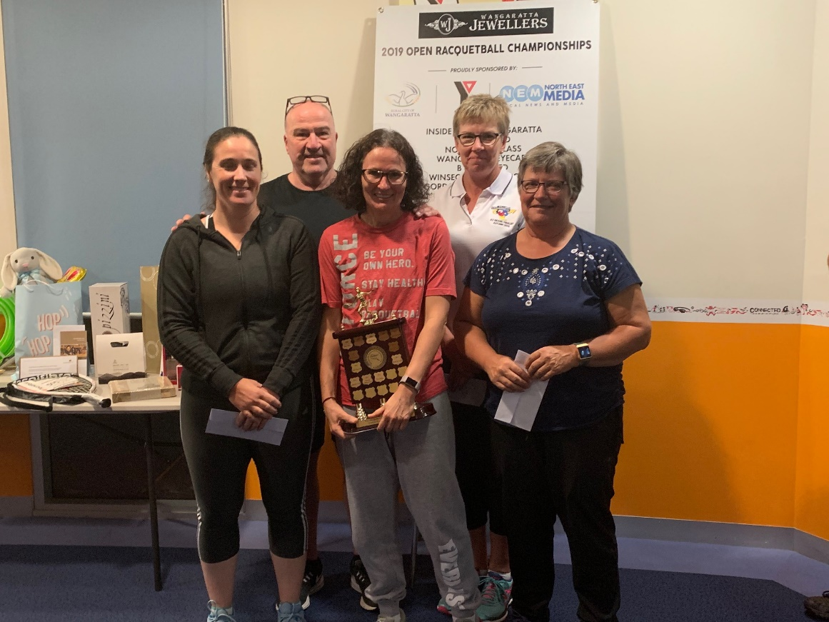WOMEN’S OPEN

The Women’s Open also attracted a high quality and evenly balanced field, but in the end, it was Geelong’s top seeded Sue Dunlop, last year’s winner and a perennial podium finisher in GP circuit events, and second seeded South Australian Corinne Yallup- Cross, who met up in the finale.

These two had met in the final of the recent South Australian Open with Yallup-Cross coming out on top in straight games, but on this occasion it was Dunlop who came out the victor after many long rallies and unbelievable returns, 21/18, 21/14, and claim consecutive Wangaratta Open titles, plus remain on top of the Victorian GP rankings table. *L-R: Corinne Yallup-Cross, Sue Dunlop, Carolyn Takle, Kathy Donnolley*

In their respective semi-finals, Dunlop overpowered SS&A’s Kathy Donnolley, 21/9, 21/8, whilst Yallup-Cross overcame Commercial Club’s third seeded Carolyn Takle, 21/9, 21/8.

A Grade

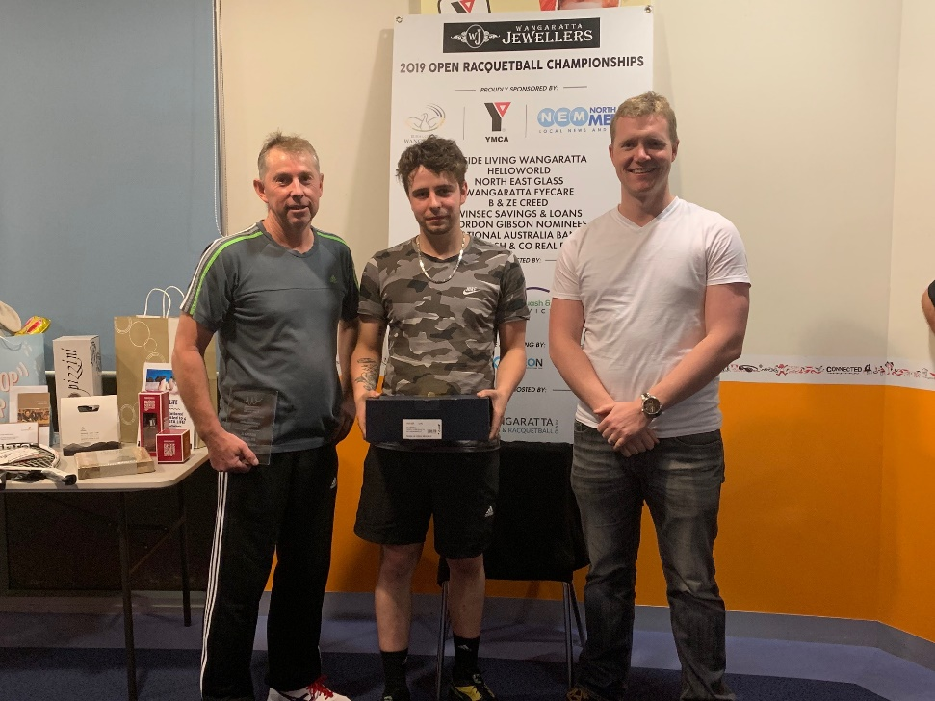Although only a small field of four faced the starter for this event, there was a lot of interest centring on Lakes Entrance’s 2018 Australian Open B Grade Champion Jordan Round’s move into the A Grade event which contained top seeded South Australian Dean Cross, 2018 Victorian GP B Grade Champion Steve Theologou and Wangaratta’s ultra-consistent Dean Milligan, who recently competed in a fifty kilometre marathon in preparation for this event.

To underline the evenness of this field every match played could have gone either way, but in the end it was Rounds who won all three of his matches, including the decider over Cross, 22/20, 21/19, with Theologou overcoming Milligan, 21/15, 22/20, to claim third placing and put him in a three way tie at the top of the rankings table with Rounds and Westerfold’s James Long.

*L-R: Dean Cross, Jordan Rounds & Matt Barry*

B Grade

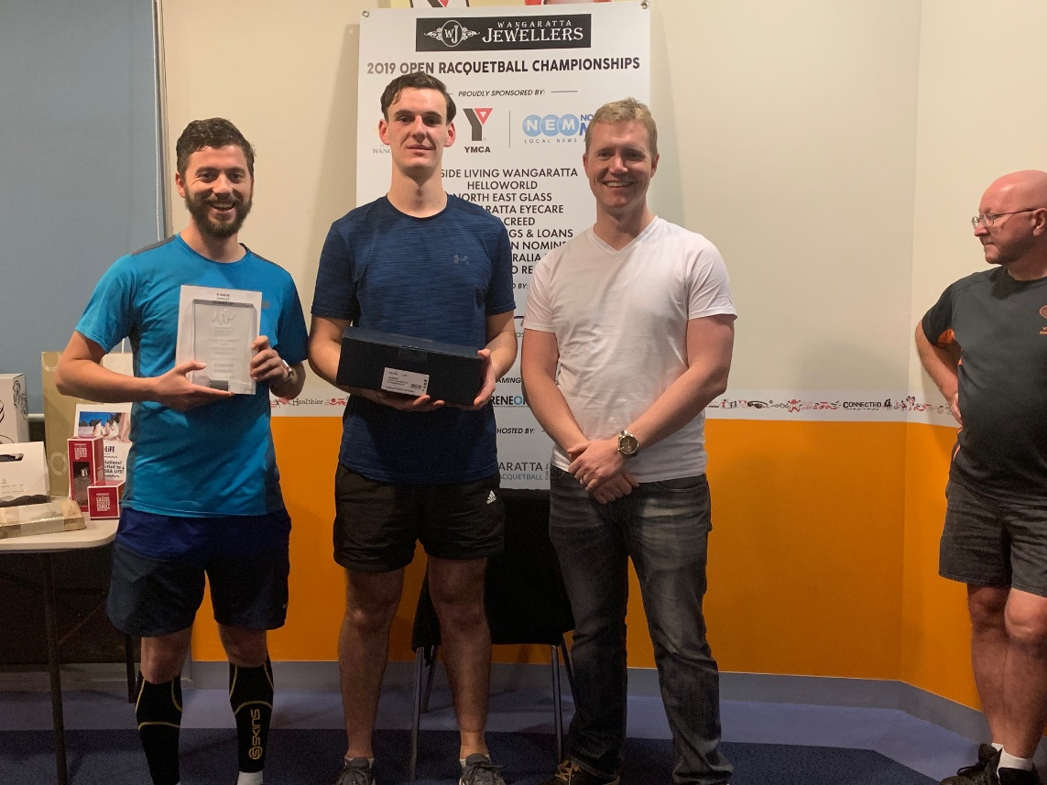

*L-R: Blake Caspersz, Kyle Magee & Matt Barry*

The top seed for this event was Ballarat’s Blake Caspersz, who had won the 2018 Ballarat Open and was runner-up in the 2019 ESRA B grade events at his two previous GP appearances, but there was no doubt that Commercial Club’s third seeded Kyle Magee was going to be a tough nut to crack following his semi final loss to Jordan Rounds in the 2018 Australian B Grade event, although that was his only GP event in the past eighteen months.

In the end both players reached the final climax, but not without both surviving tough semi final encounters, with Caspersz edging out SS&A’s Cory Sutcliffe, 21/14, 17/21, 21/17, and Magee staving off a brave challenge from his Wodonga stable mate Campbell Shobbrook, 21/17, 22/20.

The final was an epic event, with the lead continually changing throughout until Magee won the 111th point of the match and taking the title, 21/13, 20/22, 21/14, but at least there was some consolation for Caspersz as his second placing elevated him to the top of the rankings table.

C GRADE

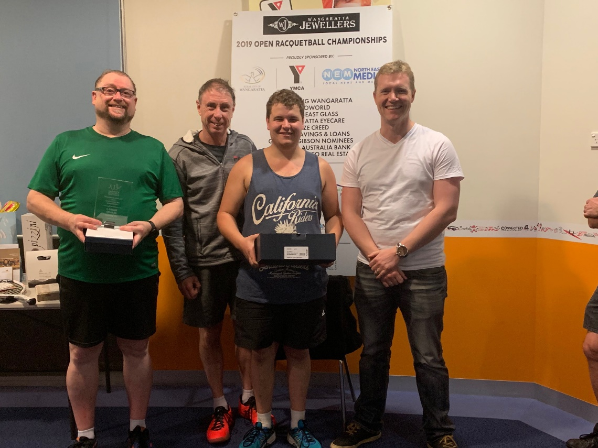

*L-R: Ron Iverson, Michael Smits, Chris Rounds & Matt Barry*

In what was the largest and most even field on the singles program, it was Lakes Entrance’s Chris Rounds who stormed through the field winning all four matches, the last three in three games, to make it a family double, as his brother Jordan took out the A Grade event, and if that was not enough, they also captured the A Grade doubles title on the Sunday.

After overcoming local hope Shaun Quinn in straight games, Rounds had the temerity to knock over Wodonga’s second seeded Justin Chu, 19/21, 22/20, 21/17, and Commercial Club’s third seeded Alex Brigden, 20/22, 21/19, 21/18.

Meanwhile, SS&A’s “ Warhorse” and eighth seeded Ron Iverson, was putting the sword to all and sundry in the top half of the draw, including Wangaratta duo Peter Anderson, 19/21, 22/20, 21/17, and Rod Dunbar 21/7, 21/12, who had earlier eliminated top seeded Michael Brigden, then coming from a game down to outlast Commercial Club’s fifth seeded Tim Darmody, 21/22, 21/17, 21/17.

As with many other singles contests at this tournament, the final was another lengthy and spine tingling encounter with Rounds finally capturing the title, 21/11, 15/21, 21/19, with the final point being the 413th that he had played throughout this event, which was only 17 points more than what Iverson had played in.

The win has him now sharing the lead on the rankings table with Mt. District’s Robert Collins.

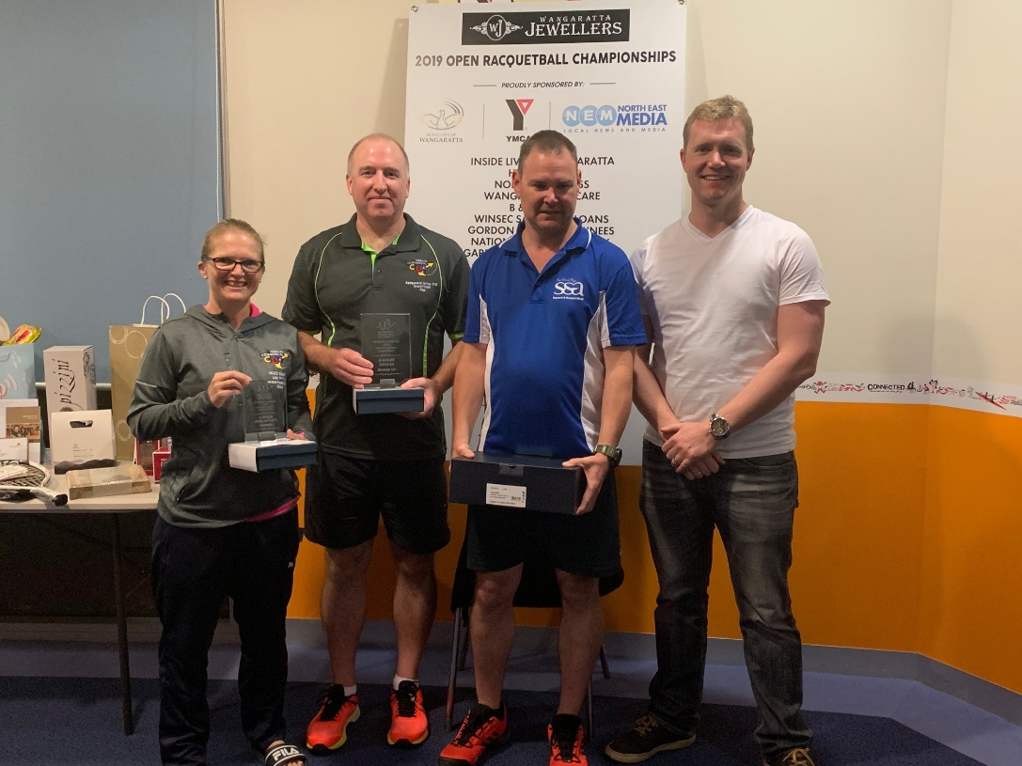D GRADE

This event contained players from three states, many who have played in several GP events, with the Commercial Cub duo of Paul Morgan and Cheryl Brigden seeded to meet in the finale, but the virtual unknown was Scott Haberecht who had only played in one GP event, the 2018 Australian Open where he lost at the quarter final stage.

Morgan was unstoppable in the top half of the draw, reaching the final after accounting for eighth seeded Marion Baines and fifth seeded Leanne Haley in straight games at the quarter and semi-final stages respectively. *L-R: Cheryl Brigden, Paul Morgan, Scott Haberecht, Matt Barry*

In the bottom half of the draw the surprise packet was Haberecht, coming from a game down to oust the second seeded Brigden, 6/21, 21/8, 21/17, at the quarter final stage, then overpowering Corio’s third seeded Ben Bell in his penultimate match.

The final was another epic battle as the two players went point for point for seventy minutes prior to Haberecht winning the 117th and final point and claiming the title, 22/21, 19/21, 21/13, and now sharing the lead on the rankings table, with Dromana’s Nelson Howard.

E GRADE

This event was littered with players of various ages from across the state, including three GP debutants, plus two players from the Commercial Club who have had limited participation in GP events over the past two years, Gail Mulloy and Peter Fagan, but who eventually fought out the final rendition of this event.

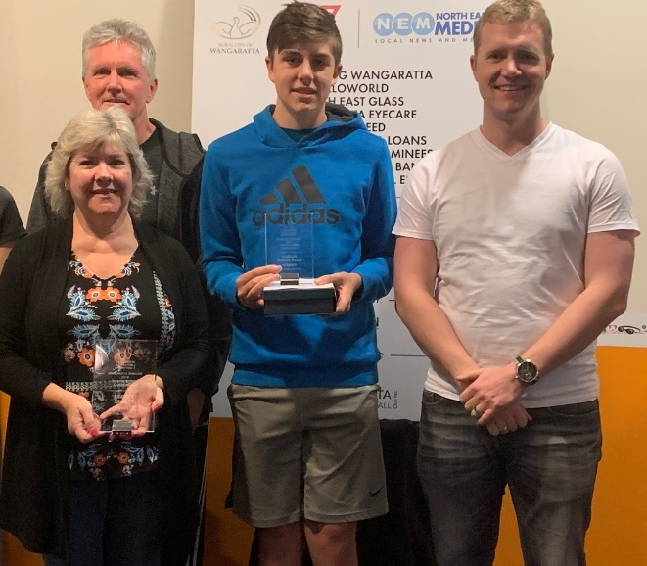As with virtually all the singles finals another action packed and lengthy final ensued, with Fagan coming from a game down to annex the title, 18/21, 21/16, 21/19, which now places him in second position behind Dromana’s Jacqueline Wilcock on the rankings table.

Their pathway to the final included Mulloy falling over the line against Wangaratta’s fifth seeded Mitchell Hobbs, in their mammoth quarter final encounter, 18/21, 21/15, 22/21, and then again to come from a game down to oust top seeded Wilcock, 10/21, 21/14, 21/14, at the semi stage, whilst Fagan progressed through to the final chapter on the back of two straight game victories over Wangaratta’s Matt Hobbs and Commercial Club’s third seeded Lillian Brigden.

*L-R: Gail Mulloy, Peter Fagan, Mitchell Hobbs & Matt Barry*

F GRADE

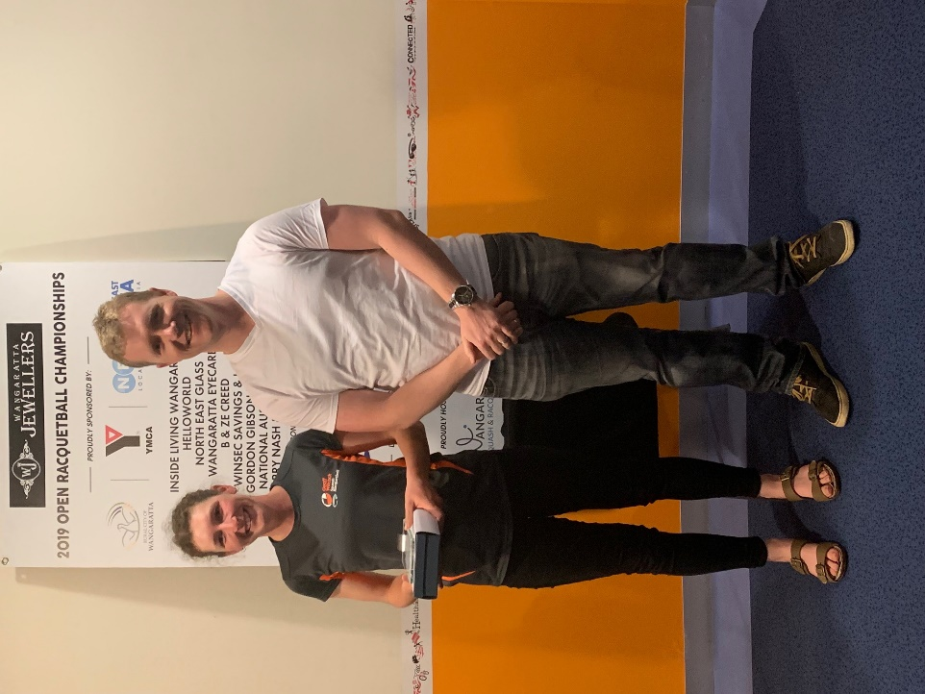Jessica Wilcock also played in the E Grade event and was declared the winner of this event and has skipped away with a very handy lead on the rankings ladder.

*L-R: Jessica Wilcock & Matt Barry*

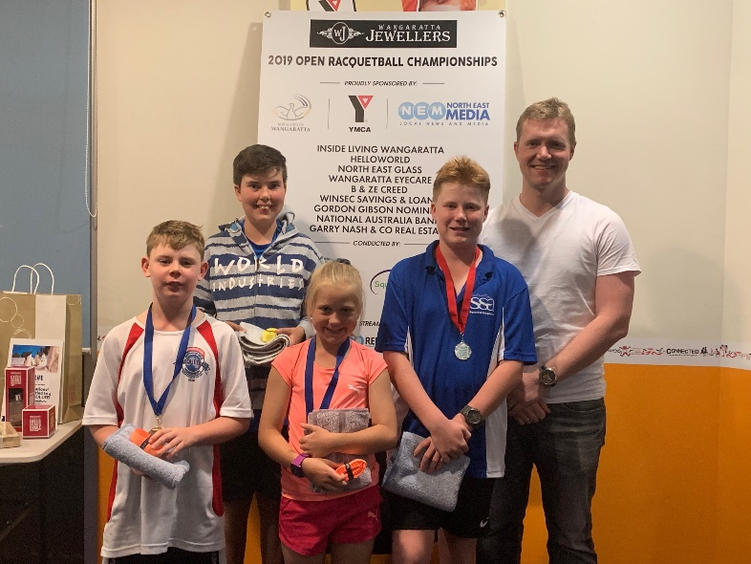Junior Under 13’s

This was a five player round robin event with Commercial Club’s pocket dynamo Amelia Brigden claiming the Girl’s event, whilst in the Boy’s section the SS&A’s Haberecht brothers, Connor and Harrison, fought it out for household bragging rights with Connor just finishing on top and taking the title, 21/17, 20/22, 21/18, with Wangaratta duo, Campbell Hobbs and Xavier Dodgshun finishing in third and fourth place respectively.

*L-R: Connor Haberecht, Campbell Hobbs, Amelia Brigden, Harrison Haberecht & Matt Barry*

**DOUBLES EVENTS – SPECIAL PRESENTERS – ELAINE & JAGGER BROADWAY**

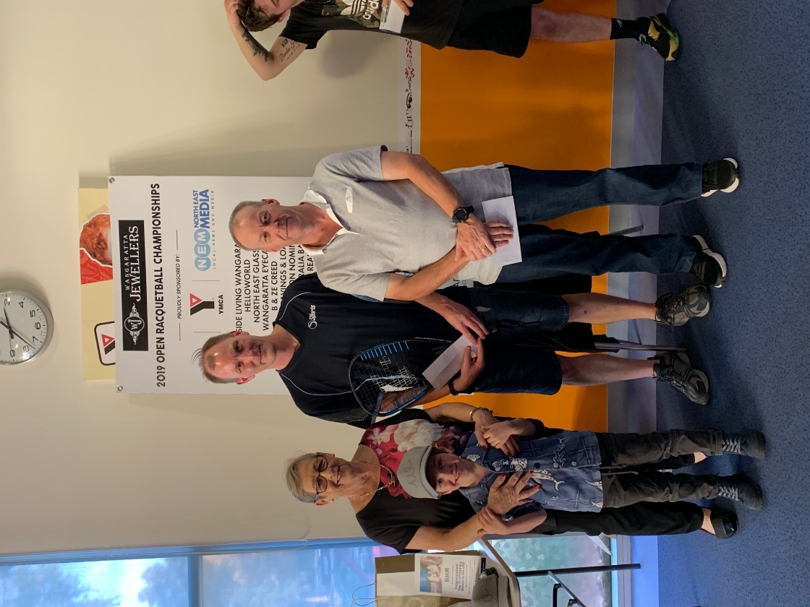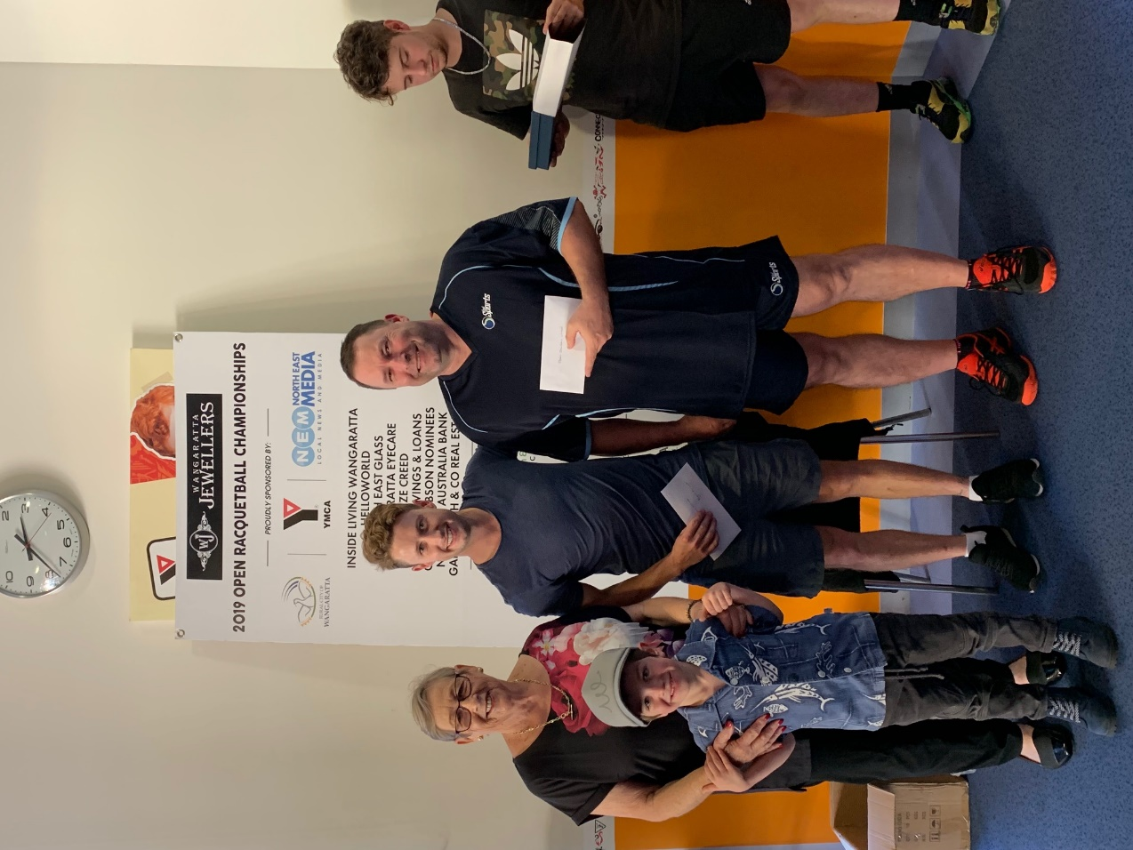

*OPEN: L-R: Winners: Ryan McCarter, Geoff Wilcock Runners-Up: Darren O’Donnell, Charlie Stevenson*

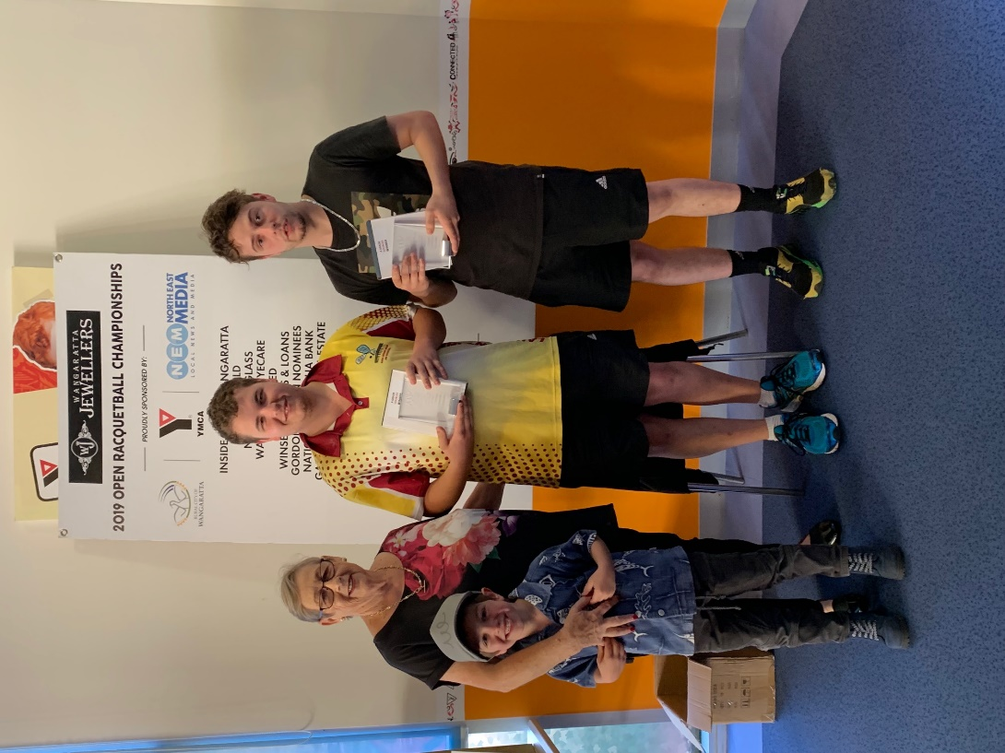 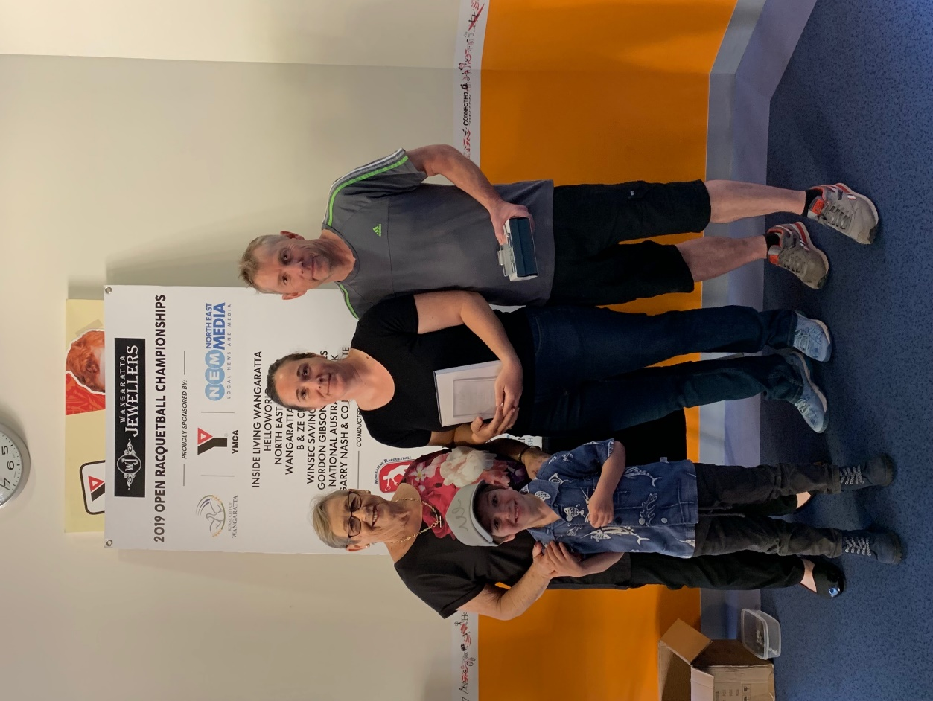

*A Grade: L-R: Winners: Chris & Jordan Rounds Runners-Up: Corinne Yallup-Cross, Dean Cross*

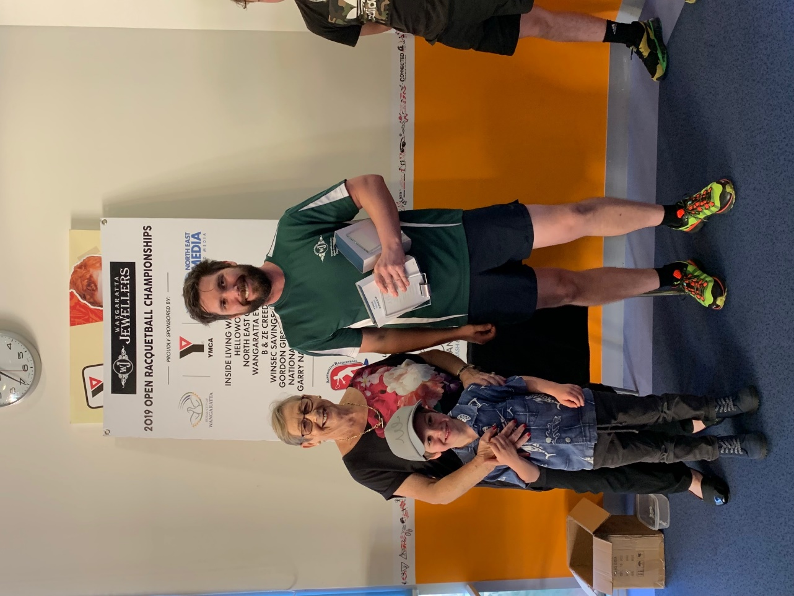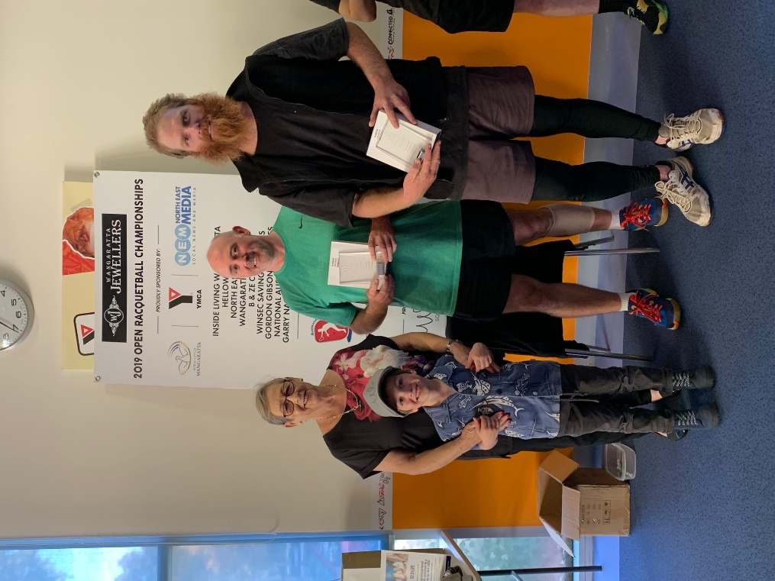

*B Grade: L-R: Winners: Paul Trinick, Brett Dinning Runners-Up: Campbell Shobbrook, (Missing – Laura Shobbrook)*

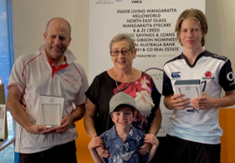 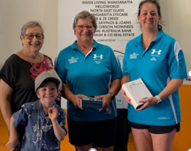

*C Grade: L-R: Winners: Michael & Alex Brigden Runners-Up: Kathy Donnolley, Michelle Sutcliffe*

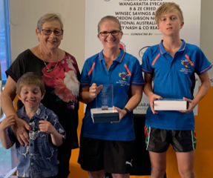*D Grade: Winners: Cheryl & Xavier Brigden*

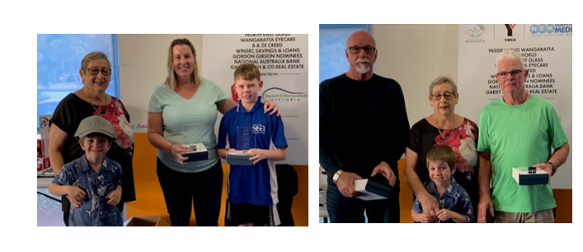

*E Grade: L-R: Runners-Up: Tracey & Connor Haberecht Winners: John Carle, Frank Dunk*

|  |  |  |
| --- | --- | --- |
| SINGLES | | |
| Grade | **Winner** | **Runner-Up** |
| Men’s Open | **Ryan McCarter** | **Garry Pedersen** |
| Women’s Open | **Sue Dunlop** | **Corinne Yallup-Cross** |
| A | **Jordan Rounds** | **Dean Cross** |
| B | **Kyle Magee** | **Blake Caspersz** |
| C | **Chris Rounds** | **Ron Iverson** |
| D | **Scott Haberecht** | **Paul Morgan** |
| E | **Peter Fagan** | **Gail Mulloy** |
| F | **Jessica Wilcock** | **N/A** |
| Junior Girls | **Amelia Brigden** | **N/A** |
| Junior Boys | **Connor Haberecht** | **Harrison Haberecht** |

|  |
| --- |
| DOUBLES |
| Grade Winner Runner-Up |
| Open G. Wilcock/R. McCarter D. O’Donnell/C. Stevenson |
| A Chris & Jordan Rounds D. Cross/C. Yallup-Cross |
| B B. Dinning/P.Trinick Cam & Laura Shobbrook |
| C Alex & Michael Brigden K. Donnolley/M.Sutcliffe |
| D Xavier & Cheryl Brigden B. Francese/J. Redmond |
| E J. Carle/F. Dunk Connor & Tracey Haberecht |

Words: Paul Vear

Photos: Courtesy of Molly Milligan